Ideation Phase
Define the Problem Statements
Date | 14 July 2026
Team ID
Project Name | HouseRent India — MERN Property Rental & Sale Platform
Maximum Marks | 2 Marks

Customer Problem Statement Template:
A well-articulated customer problem statement allows the team to find the ideal solution for the challenges HouseRent India's users face, in the classic "I am ... trying to ... but ... because ... which makes me feel ..." format.

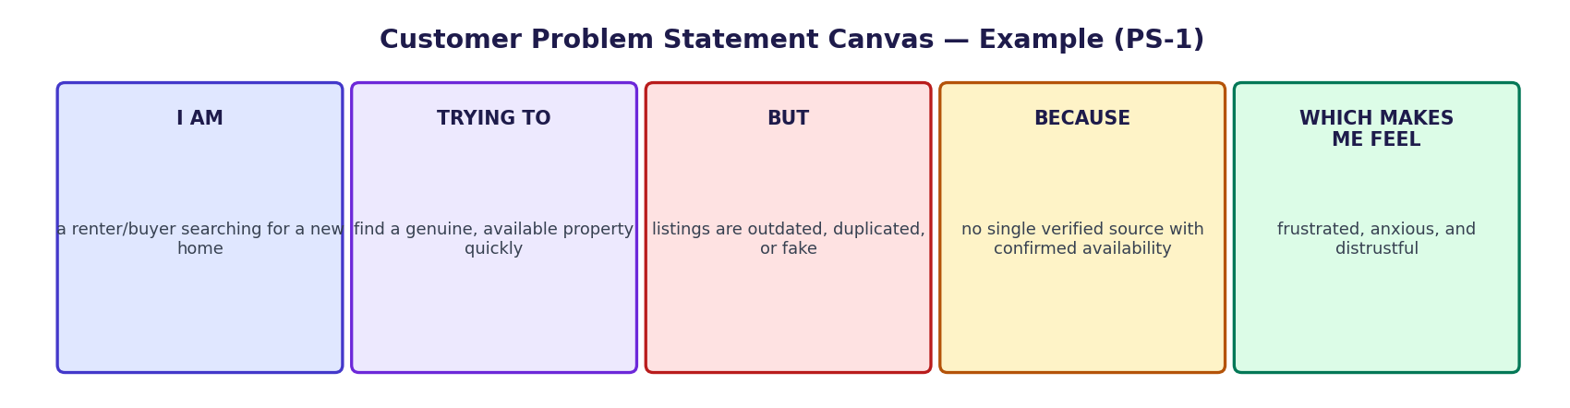
Figure 1: Problem statement canvas — worked example for PS-1

PS | I am (Customer) | I'm trying to | But | Because | Which makes me feel
PS-1 | a renter/buyer searching  for a new home | find a genuine, available  property quickly | listings on classifieds and  broker groups are outdated,  duplicated, or fake | there is no single verified  source with real photos and  owner-confirmed availability | frustrated, anxious about my  move-in deadline, and  distrustful of the process
PS-2 | a property owner with  units to rent or sell | reach serious tenants/buyers  without constant phone calls | enquiries come in unstructured  via calls/WhatsApp with  no record | there is no dashboard to  list, track, and respond to  requests in one place | overwhelmed and unsure who  is a genuine, ready buyer
PS-3 | a renter/buyer who has  sent a booking request | negotiate details or ask  questions directly with the owner | there is no direct channel  once a request is sent | communication happens only  over personal phone numbers,  which feels unsafe | hesitant to share personal  contact details with a stranger
PS-4 | a platform admin | keep the marketplace free  of policy-violating listings | I cannot unilaterally take a  listing down without  due process | owners deserve a fair,  consent-based removal flow  rather than silent deletion | cautious about overstepping  an owner's ownership rights

